**Finance Report – Members Committee Meeting 24 February 2022**

**December & January Results**

Trading throughout December and January has declined compared to November and October results. We are also now trading at a level lower than the lockdowns back in August and September 2021. In December, we made a net loss of $4,898 and in January we made another net loss of $6,901. The table below sets out a summary Profit and Loss for January 2022 as compared to December 2021:



Notes:

1. Daily shop trading figures have dropped off significantly ($1,977in December, down to $1,696 in January. Refer to below store trading update which details recent daily shop trading trends.
2. January subscription fees have been manually adjusted based on Paypal receipts and reports provided by Ran prior to her exiting her actin Manager’s role.
3. January rent was paid in December, and subsequently adjusted on the above profit and loss.

**Store Trading Update**

Based on recent shop trading data for November, December and January, the average daily sales have dropped off again. We need to understand why the sales have dropped off so significantly (about $300 per day when compared to September). The MC needs to consider and discuss reasons for the significant drop-off in daily sales figures. The MC also needs to discuss potential changes at a store level to help control costs associated with running the Co-op given the reduction in turnover. A high priority will be to discuss the level of staff being rostered on. It is my view that we need to revisit the rosters and adjust the level of staffing to be commensurate with the expected daily sales. The table below sets out the average daily shop revenue by month for the last twelve months:



The below chart sets out the daily trading trends between 1 June 2021 and 22 February 2022:

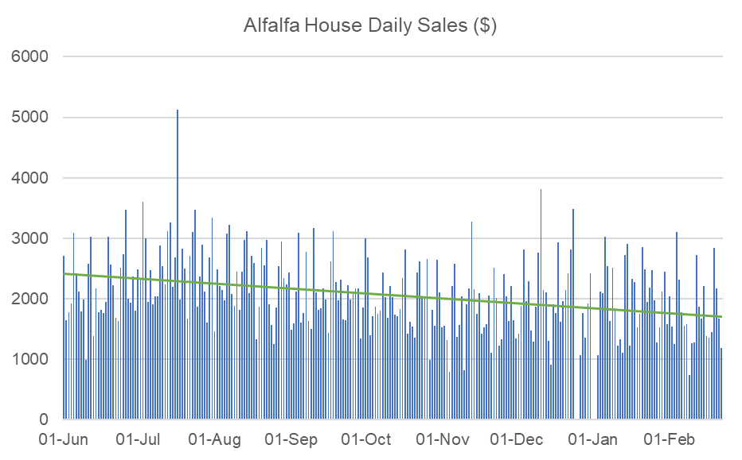

**NSW and Federal Government COVID Support**

Please see below updates in relation to the current NSW Government COVID Support Programs.

1. **Fees & Charges Rebate**

The NSW Government has announced it is increasing the Government fees and charges rebate to $2,000. The rebate allows eligible businesses and not-for-profits to claim government fees and charges paid since 1 May 2021. We are eligible for this rebate, however, we have only paid $407.50 in council rates since 1 May 2021. I recently lodged an application with Service NSW to obtain this rebate and we are waiting to hear back from Service NSW regarding our approval for the scheme.

1. **2022 Small Business Support Program**

The 2022 Small Business Support Program is designed to help businesses survive the immediate impact of the Omicron COVID-19 strain. It is for the month of February only.

* Eligible employing businesses and not-for-profit organisations will receive 20% of their weekly payroll as a lump sum for the month of February, with a minimum payment of $750 per week and a maximum payment of $5,000 per week.
* Non-employing businesses will receive $500 per week, paid as a lump sum of $2,000.
* Businesses with a turnover of between $75,000 and $50 million that experienced a minimum 40% decline in turnover in January 2022, and in the first fortnight of February 2022, will be eligible to apply.

I lodged an application with Service NSW on 18 February 2022 and we have since been approved for the scheme. We are still awaiting payment, however, I believe we will only receive $750 per week for the month of February, which is equal to $3,000 total payment.