**Finance Report – Members Committee Meeting 25 November 2021**

**October Results**

Trading throughout October was largely improved when compared to September, with net profit improving considerably off the back of a reduction in spending. In September, we made a net profit of $4,584 as compared to $12,604 in October. The table below sets out a summary Profit and Loss for October 2021 as compared to September 2021:



Notes:

1. Daily shop trading figures were flat in October ($2,052 in September vs $1,994). Refer to below November trading update which details recent daily shop trading trends.
2. Throughout the month, we received 1 instalments $3,000 from the NSW Government as part of the JobSaver Scheme. We are still eligible for the JobSaver payment, and we are required to resubmit our eligibility every two weeks ongoing. We also received a $7,500 one-off grant as part of the NSW COVID Small Business Grants.

**November Trading Update**

Throughout October we saw relatively flat average daily shop sales when compared to September. Based on recent shop trading data for November, the average daily sales have dropped off again. We need to understand why the sales have dropped off so significantly (about $200 per day when compared to September and October). We also need to understand why Wednesday’s are our worst trading days. The data shows we consistently struggle to hit $1,000 revenue on Wednesdays over the past few months. Potential options for the MC to look at would be to close the store on Wednesdays, or otherwise limit the staff rostered on. The table below sets out the average daily shop revenue by month since 1 January 2021:



The below chart sets out the daily trading trends between 1 June 2021 and 23 November 2021:

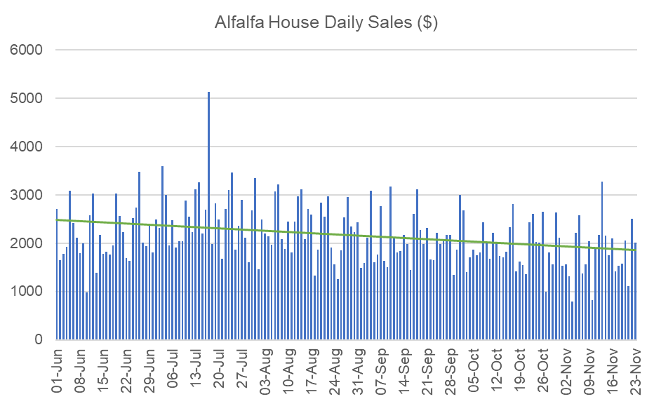

**FY21 Statutory Accounts & Financial Report**

We have now finalised and executed the Financial Report for FY21. I will be lodging this with Fair Trading this week. A copy of the Financial Report is attached to this finance report.

**NSW and Federal Government COVID Support**

Please see below updates in relation to the NSW Government COVID Support Programs. I have kept the descriptions of each program and our eligibility below. Updates since our last MC meeting are highlighted in yellow.

1. **JobSaver**

The NSW Government also announced a JobSaver support program for eligible businesses, which includes fortnightly payments of up to 40% of the weekly payroll of a business (minimum $1,500, maximum $10,000). The only eligibility requirements for this program are for the business to have turnover between $75,000 and $50 million, and be able to prove a revenue decline of 30%.

These grants are now available depending on the decline in turnover experienced over a minimum 2-week period from 26 June 2021 onwards, compared to the same period in 2019 OR 2020 (previously only 2019 could be used). Furthermore, eligible businesses also now have the ability to use a comparison period immediately prior to the lockdown on 26 June (i.e. 12 June 2021 to 25 June 2021). Please note the different comparison periods for this government support package. We have the ability to use comparison periods up to today’s date (i.e. we can choose a minimum 2-week period between 26 June 2021 and 25 August 2021).

In the attached excel workbook which analyses our eligibility for the JobSaver program, you will note that we are able to show a 30% decline in revenue for several 2-week periods in early June, including the comparison period immediately prior to lockdown (i.e. 12 June 2021 to 25 June 2021). However, the new comparison periods for calculating the decline in revenue for the JobSaver are also ambiguous. There is no guidance as to whether this comparison period immediately prior to lockdown should be compared to a 2-week period after the lockdown started on 26 June, or alternatively, compared to the same period in 2020 and 2019.

Despite this, we know trading has been down throughout August, so for the JobSaver program, we needed to analyse the August results against 2019 and 2020. When looking at the 2-week periods throughout August, we didn’t quite get to a 30% decline (29% was the highest). However, the comparison period is a MINIMUM 2-week period. If we compare revenue from the 19-day period 1 August – 19 August, we have achieved a 30.06% decline as compared to 2019 ($62,801.00 in 2019 vs $43,923.64 in 2021).

I am confident that we have done enough to qualify for the JobSaver program, and we should be eligible to receive 40% of our gross wages paid by the NSW Government or $3,000 at a minimum. Our fortnightly wages bill is around $14,000/month, which means we should expect to receive about $3,000/fortnight under the JobSaver program. It is unclear whether the NSW Government will backdate the payments to the start of lockdown, or to the start of the comparison period (i.e. 1 August 2021).

**We applied for the JobSaver program on 30 August 2021. We were subsequently approved to receive payments under the program, and as at 26 October 2021, we have received $15,000 from the NSW Government, with another $3,000 expected to be received next week. We are required to reconfirm our eligibility every two weeks. However, we should remain eligible unless we miraculously start hitting the $3,000 average daily sales number, or the NSW Government pulls the rug out from under us. The program is still ongoing, with the last eligible period being 8 November – 21 November 2021. We do not have any visibility over when this program will end.**