**Finance Report – Members Committee Meeting 28 October 2021**

**September Results**

Trading throughout September was down compared to August, with total shop revenue decreasing 15% month on month. In August, we made a profit of $7,429. The table below sets out a summary Profit and Loss for September 2021 as compared to August 2021:



Notes:

1. Daily shop trading figures decreased throughout September ($2,302 in August vs $2,052 in September). Refer to below October trading update which details recent daily shop trading trends.
2. Throughout the month, we received 4 instalments of $3,000 from the NSW Government as part of the JobSaver Scheme. We are still eligible for the JobSaver payment, and we are required to resubmit our eligibility every two weeks ongoing.
3. We also paid two rental payments in September, which led to the significant increase in rent and facility expenses.

**October Trading Update**

Throughout September we saw a drop-off in the average daily shop sales. The drop-off in September was somewhat expected given the changes to restrictions and many of our members not being able to shop with us in store. Based on recent shop trading data for October, the average daily sales have levelled off. However, the current level of average daily sales is still only marginally less than the average daily sales of May and June (i.e. prior to lockdown restrictions). The table below sets out the average daily shop revenue by month since 1 January 2021:



The below chart sets out the daily trading trends between 1 June 2021 and 26 October 2021:

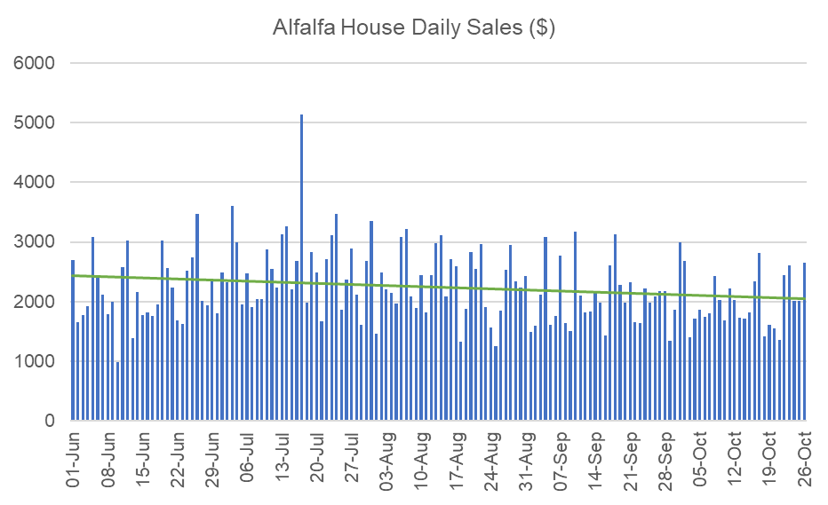

**FY21 Statutory Accounts & Financial Report**

I spoke to our external accountant on Tuesday. We have still not received our financial reports. Apparently, there is some back-and-forth between the accountant and the bookkeeper to properly reconcile the accounts. I have been told I will get the financial reports in the next week.

I expect to be in a position to table the financial reports for approval and signature at the next MC meeting. I am hoping that I can circulate the report a couple of weeks prior to the next MC meeting to ensure we have enough time to review. Our lodgement deadline is 31 December 2021, so we still have plenty of time to get it right.

To give you an idea of how our financial position has changed over the past 12 months, I have attached a Balance Sheet comparison of October 2021 vs October 2020. The most pleasing part of this analysis is the improvement of our net asset position. We have increased our net asset position by $31,500 in the past 12 months (a huge 51% increase).

**Data Analysis Activities**

I have attached to this Finance Report some data analysis which has been prepared by our volunteer, Elliot Liu. I had asked Elliot to look at the transaction data all the way back to the start of FY21 (i.e. 1 July 2020) to help inform store opening hours and staffing requirements.

There are some interesting insights and takeaways from the analysis. There are a number of potential changes/options for store opening/closing hours to be discuss, including:

* change Saturday opening time to 10am
* change Mon-Fri & Sun opening time to 11am
* change Mon-Fri closing time to 6pm
* extend Sat & Sun closing time to 6pm

All of the above options need to be discussed by the MC and store manager.

**NSW and Federal Government COVID Support**

Please see below updates in relation to the NSW Government COVID Support Programs. I have kept the descriptions of each program and our eligibility below. Updates since our last MC meeting are highlighted in yellow.

1. **NSW COVID Small Business Grant**

There are three levels of grants available to eligible businesses who can prove a reduction in turnover:

* $7,500 for a decline of 30% or more
* $10,000 for a decline of 50% or more
* $15,000 for a decline of 70% or more

The NSW has recently updated the eligibility criteria. These grants are now available depending on the decline in turnover experienced over a minimum 2-week period from 26 June 2021 to 17 July 2021, compared to the same period in 2019 OR 2020 (previously only 2019 could be used). Furthermore, eligible businesses also now have the ability to use a comparison period immediately prior to the lockdown on 26 June (i.e. 12 June 2021 to 25 June 2021).

Attached to this report is an excel workbook which analyses our eligibility for both the NSW COVID Small Business Grant and the JobSaver program (see below for JobSaver information). You will note that when looking at our eligibility for the NSW COVID Small Business Grant, we are able to show a 30% decline in revenue for several 2-week periods in early June, including the comparison period immediately prior to lockdown (i.e. 12 June 2021 to 25 June 2021).

**We are still unsure whether this will qualify us for the grant.** The new comparison periods for calculating the decline in revenue are quite ambiguous. There is no guidance as to whether this comparison period immediately prior to lockdown should be compared to a 2-week period after the lockdown started on 26 June 2021, or alternatively, compared to the same period ion 2020 and 2019. Our accountant believes there may be sufficient flexibility in the eligibility requirements for us to qualify. However, based on my understanding of the eligibility requirements, I would estimate our eligibility to be a 50/50 proposition.

**After much back-and-forth with the NSW Government, we were finally approved for this grant, and have received $7,500.**

1. **JobSaver**

The NSW Government also announced a JobSaver support program for eligible businesses, which includes fortnightly payments of up to 40% of the weekly payroll of a business (minimum $1,500, maximum $10,000). The only eligibility requirements for this program are for the business to have turnover between $75,000 and $50 million, and be able to prove a revenue decline of 30%.

These grants are now available depending on the decline in turnover experienced over a minimum 2-week period from 26 June 2021 onwards, compared to the same period in 2019 OR 2020 (previously only 2019 could be used). Furthermore, eligible businesses also now have the ability to use a comparison period immediately prior to the lockdown on 26 June (i.e. 12 June 2021 to 25 June 2021). Please note the different comparison periods for this government support package. We have the ability to use comparison periods up to today’s date (i.e. we can choose a minimum 2-week period between 26 June 2021 and 25 August 2021).

In the attached excel workbook which analyses our eligibility for the JobSaver program, you will note that we are able to show a 30% decline in revenue for several 2-week periods in early June, including the comparison period immediately prior to lockdown (i.e. 12 June 2021 to 25 June 2021). However, the new comparison periods for calculating the decline in revenue for the JobSaver are also ambiguous. There is no guidance as to whether this comparison period immediately prior to lockdown should be compared to a 2-week period after the lockdown started on 26 June, or alternatively, compared to the same period in 2020 and 2019.

Despite this, we know trading has been down throughout August, so for the JobSaver program, we needed to analyse the August results against 2019 and 2020. When looking at the 2-week periods throughout August, we didn’t quite get to a 30% decline (29% was the highest). However, the comparison period is a MINIMUM 2-week period. If we compare revenue from the 19-day period 1 August – 19 August, we have achieved a 30.06% decline as compared to 2019 ($62,801.00 in 2019 vs $43,923.64 in 2021).

I am confident that we have done enough to qualify for the JobSaver program, and we should be eligible to receive 40% of our gross wages paid by the NSW Government or $3,000 at a minimum. Our fortnightly wages bill is around $14,000/month, which means we should expect to receive about $3,000/fortnight under the JobSaver program. It is unclear whether the NSW Government will backdate the payments to the start of lockdown, or to the start of the comparison period (i.e. 1 August 2021).

**We applied for the JobSaver program on 30 August 2021. We were subsequently approved to receive payments under the program, and as at 26 October 2021, we have received $15,000 from the NSW Government, with another $3,000 expected to be received next week. We are required to reconfirm our eligibility every two weeks. However, we should remain eligible unless we miraculously start hitting the $3,000 average daily sales number, or the NSW Government pulls the rug out from under us.**